CREATE A DATABASE IN CLOUDANT DB

Date | 26-10-2022
Team ID | PNT2022TMID01082
Project Name | Project - IOT based safety gadget for child safety monitoring and notification
Maximum Marks | 4 Marks
Submitted By | A.Prem kumar

Create A Database In Cloudant DB
Aim: To create a database in Cloudant DB to store location data.

Steps followed:
- Logged in to IBM Cloud account
- Navigated to `./resources`
- Clicked on the “Create Resource +” button
- Searched for “Cloudant”
- Chose the “Lite Version” and clicked on “Create”
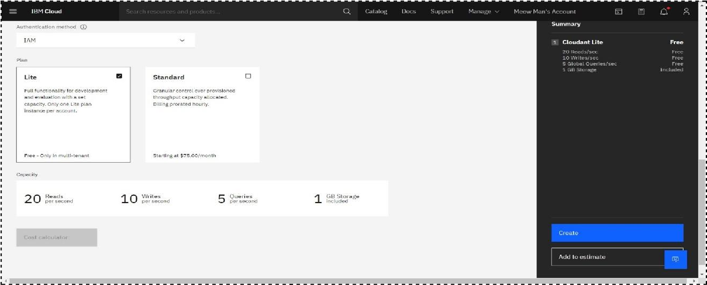
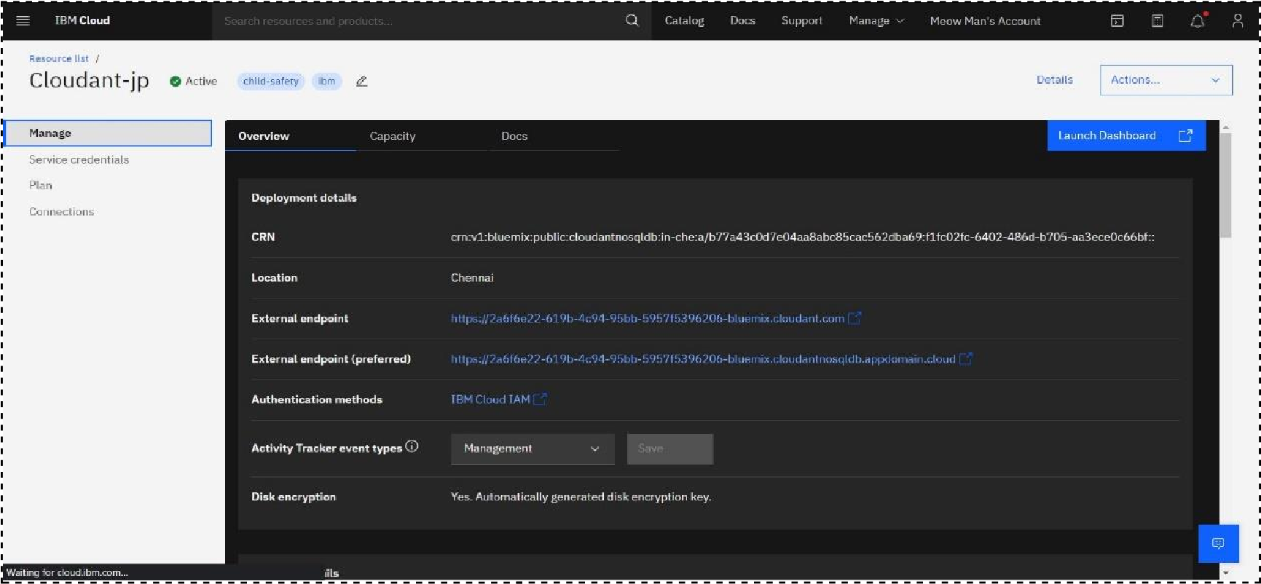
- The Cloudant database resource was created successfully
- Clicked on Launch Dashboard

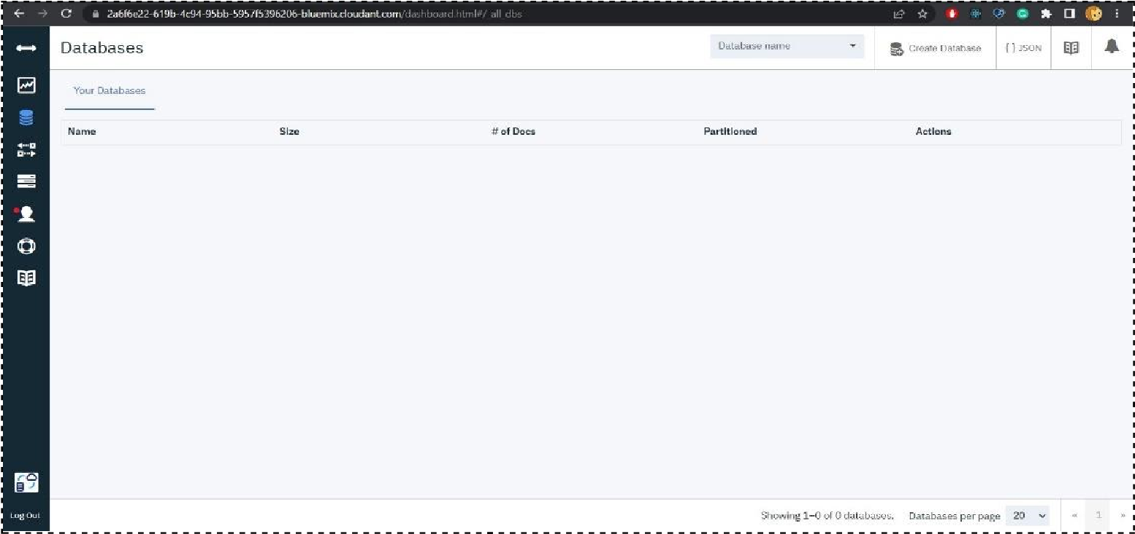

- Clicked on “Create Database”. Entered “meowman” as the database name and the “Non-partitioned” option

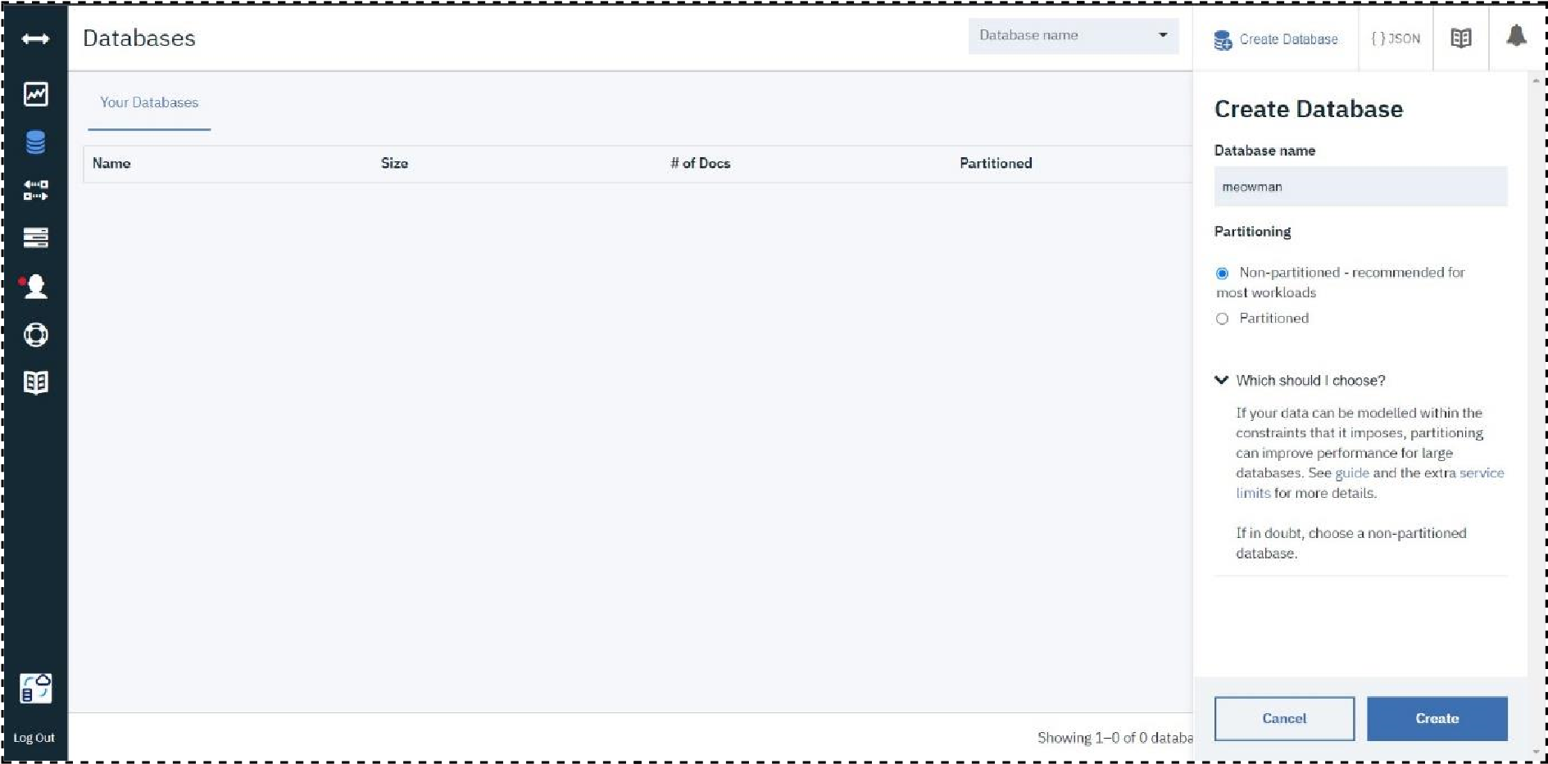
The database “meowman” was created successfully

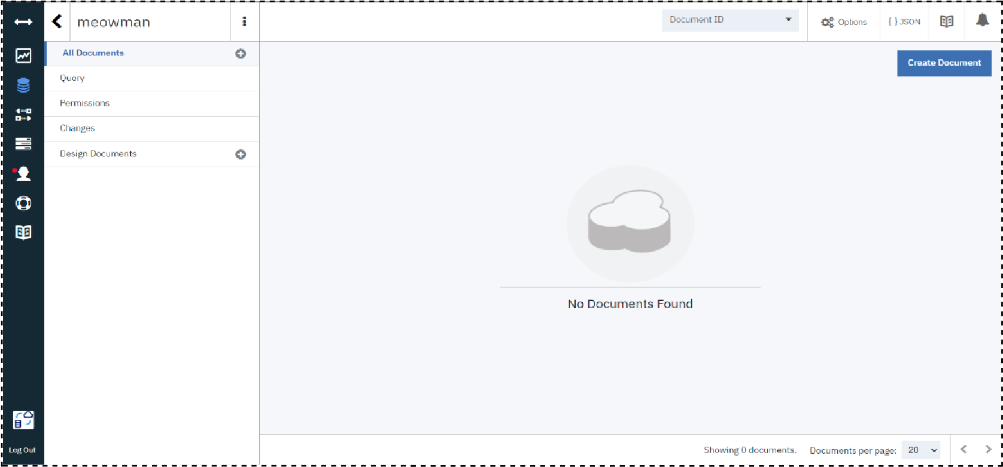

Result: A database to store the location data was created successfully on Cloudant DB

